BWEA Spirit Wear
Color Options on all items EXCEPT Denim Adult Shirt – Forest Green or Navy
Embroidered with Full Logo | Embroidered with School Name Only
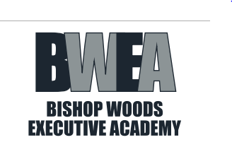  #1: Short Sleeve Polo  Adult:  S, M, L, XL - $15  2X - $17 3X - $18 4X - $19  #2: Denim Shirt  Adult:  S, M, L, XL - $25  2X - $27 3X - $28 4X - $29  #3: Polar Fleece Jacket  #3A: Adult:  S, M, L, XL - $25  2X - $27 3X - $28 4X - $29  #3B: Youth:  All sizes - $24  S (6-8), M (10-12), L( 14-16) | #4: Short Sleeve Polo  #4A: Adult:  S, M, L, XL - $15  2X - $17 3X - $18 4X - $19  #4B: Youth:  All sizes - $13  2-4, 6-8, 10-12, 14-16, 18-20

Parent Name____________________________ Student Name__________________________
Phone Number _________________Teacher/Homeroom and Grade______________________
Item # | Color (Green or Navy) | Size | Quantity | Price/each $ | Total $
Signature______________________________________ Grand Total $______________
Cash or Money Orders Only. All orders must be returned to Cara Campo no later than February 11, 2015
Thank you in advance for supporting Bishop Woods Executive Academy!

